ROMANIAN NAVAL AUTHORITY

SEARCH AND RESCUE CO-OPERATION PLAN

BETWEEN SEARCH AND RESCUE SERVICES AND PASSENGER SHIPS

Passenger Ship
M/S ………………………

Romanian Naval Authority
General Director,
Cosmin Laurenţiu DUMITRACHE

Director of Maritime
Coordination Centre
Adrian ALEXE

Elaborated by
Marius ROIBU
Head of MRCC Department

ROMÂNIA – CONSTANŢA
MRCC DEPARTMENT

2023

PLAN FOR CO-OPERATION BETWEEN
SEARCH AND RESCUE SERVICES
AND PASSENGER SHIPS
(According to the SOLAS Regulation V/7.3, Rev. 1)

List of Contents

Introduction
Description of a plan for co-operation
Corrections and updating

Part I – The Company

Part II – The Ship

Part III – Romanian search and rescue organization
3.1 Search and rescue regions (SRR)
3.2 SAR mission co-ordination (SMC)
3.3 On Scene co-ordination (OSC)

Chapter IV - SAR Facilites
4. Romania
4.1 MRCC Constanta
4.2 Communications
Digital selective calling (DSC) - map
Limits of Romanian sea areas - map
4.3 Declared SAR units
4.4 Communication plan
4.5 Search planning
4.6 Medical advice/assistance
4.7 Firefighting, chemical hazards
4.8 Shore reception arrangements
4.9 Informing next-of-kin
4.10 The decision to close up a SAR operation taken by SMC, when there is no longer any reasonable hope of rescuing survivors

Charter V – Relations with media
5. Media relations

Charter VI – Periodic exercises
6.1 Plans for exercises
6.2 Types of exercises

Introduction

The Maritime Safety Committee, at its seventy – fourth session (30 May to 8 June 2001), recalled that MSC 73, in adopting amendments to the 1974 SOLAS Convention, inter alia, revising chapter V, had also adopted Regulation V/7.3, which requires all passenger ships to which SOLAS chapter I applies, to have on board a Plan for co-operation with appropriate search and rescue services in event of an emergency.

The text of Regulation SOLAS V/7.3 is, as follows:
“Passenger ships, to which chapter I apply, shall have on board a Plan for co-operation with appropriate Search and Rescue services in event of an emergency. The plan shall be developed in co-operation between the ship, the company, as defined in regulation IX/1 and the Search and Rescue services. The plan shall include provisions for periodic exercises to be undertaken to test its effectiveness. The plan shall be developed based on the guidelines developed by the Organization”

The Maritime Safety Committee, at its ninety-eighth session (7 to 16 June 2017), having considered the recommendations made by the Sub-Committee on Navigation, Communications and Search and Rescue at its fourth session (8 to 10 March 2017), approved the revised Guidelines for preparing plans for cooperation between search and rescue services and passenger ships (in accordance with SOLAS regulation V/7 revoking MSC/Circ.1079

The aim of SAR co-operation planning, developed in accordance with the guidelines mentioned above, is to enhance mutual understanding between a ship, a company and SAR services so that, in the event of an emergency, all three parties will be able to work together efficiently. This is best achieved by the prior exchange of information and by conducting joint emergency response exercises.

Description of a Plan for co-operation

A Plan for co-operation will consist of six parts and the information given therein can be divided into the following areas:
- Company information,
- The ship,
- The MRCC,
- SAR facilities,
- Media relations,
- Periodic exercises.
The plan should be made up in accordance with guidelines approved by MSC.1/Circ.1079/Rev.1.

PART I

The Company

Name and Address:

Contact List:

24-Hour emergency initial and alternative contact arrangements:

further communications arrangements (including direct tel./fax links to relevant personnel):

Chartlet(s) showing details of route(s) and service(s) together with delimitation of relevant search and rescue regions (SRRs)

Liaison arrangements between the company and relevant RCCs

Provision of relevant incident information

Provision of liaison officer(s)

PART II

The Ship(s)

[ship 1]

Basic details of the ship

MMSI

IMO Number

Call Sign

Country of Registry

Type of ship

Gross Tonnage

Length Overall (in meters)

Maximum permitted draught (in meters)

Service speed

Maximum number of persons allowed on board.

Number of crew normally carried.

Medical facilities

Communication equipment carried

Simple plan of decks and profile of the ship, including basic information on:

Life saving equipment

Fire fighting equipment

Plan of helicopter deck, if fitted

Plan of winching area, if fitted, including approach sector

Means on board intended to be used to rescue people from the sea or from the other vessels

and a color picture of the ship

PART III

The MRCC

search and rescue regions along the route

The Romanian Search & Rescue Department could perform SAR operations within the region delimitated by latitudes and longitudes, from north to south:

 | Lat. | Lon.
1 | 45°12’00” N | 029°40’00” E
2 | 45°09’00” N | 029°58’00” E
3 | 45°05’18.5” N | 030°02’45” E
4 | 45°03’18.5” N | 030°09’24.6” E
5 | 44°46’38.7” N | 030°58’37.3” E
6 | 44°44’13.4” N | 031°10’27.7” E
7 | 44°02’53.0” N | 031°24’35.0” E
8 | 43°44’20” N | 031°22’10” E
9 | 43°44’20” N | 028°34’51” E

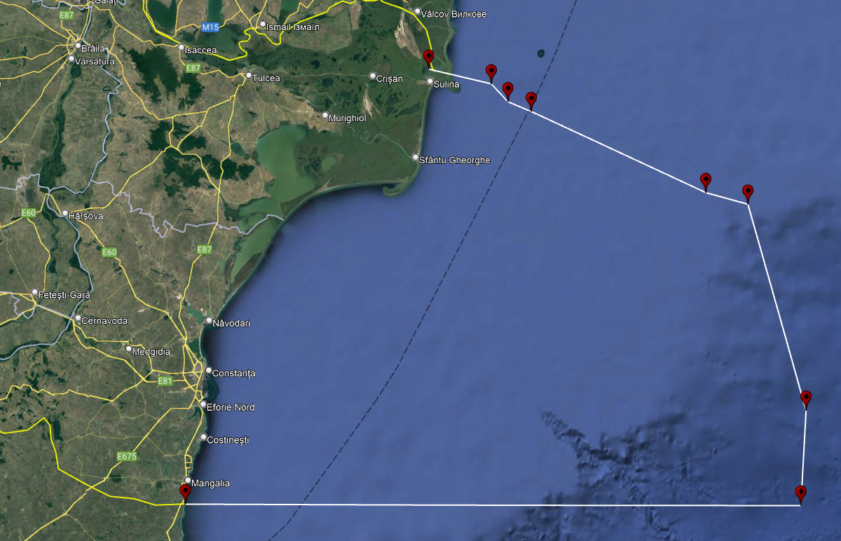

SAR mission coordinator (SMC)

The SAR coordination function is provided by the Romanian Naval Authority through MRCC.

The MRCC service is permanently manned by duty officers (SMC) in charge with the co-ordination of SAR missions. Working program is 24 hours basis. Additional personnel is always available to support incident response team.

The responsibilities of SMC are in accordance with the International Aeronautical and Maritime Search and Rescue Manual (IAMSAR Manual), volume II.

The SAR air co-ordination for the incidents at sea within the Romanian SRR is provided by MRCC Constanta in cooperation with the Romanian Air SAR Co-ordination Centre – ROMATSA Bucureşti.

On Scene Coordinator (OSC)
The SAR Mission Co-ordinator (SMC) from MRCC, nominate the On-Scene Co-ordinator (OSC), which may be the person in charge of a search and rescue unit (SRU), ship or aircraft participating in a search, or someone at another nearby facility in a position to handle OSC duties in accordance with the International Aeronautical and Maritime Search and Rescue Manual (IAMSAR), volume II, Chapter I, item 1.2.4.

PART IV

SAR Facilities

Romanian SRR

MRCC Constanta
Ministry of Transport and Infrastructure
Romanian Naval Authority
Maritime Rescue Co-ordination Centre
Incinta Port, Cladirea ANR, 900900, Constanța, Romania
Telephone : | + 40.(0)723634122  + 40.(0)740173032  + 40.(0)724165949
Fax | + 40.(0)241606065
E-mail | mrcc@rna.ro

Communications

Constanţa MRCC:
Watch H24: VHF 16 and 70 DSC
MF 2182 and 2187,5 DSC
MMSI: 002640579

Within the Romanian SRR, GMDSS is established along the Romanian coast. The Romanian SAR service uses the VHF/MF/HF equipment of MRCC Constanţa.
- Shore-ship-shore communication is achieved by MRCC Constanta own infrastructure in accordance with GMDSS requirements. Sea areas, A1: Ch 70, A2:2187.5 kHz, A3/A4: 4, 6, 8, 12 and 16 MHz.
- MF stations serve as GMDSS R/T continuous base (24 hours) on frequency of 2182 kHz.
- VHF stations continuously monitor channel 16 (156.8 MHz). Antenna sites are located at Sf. Gheorghe, Sulina, Constanta and Mangalia.
- Romania has ratified INMARSAT-76 with its amendments.
- NAVTEX stations through VARNA RADIO (on behalf of Romania).

For full details and location of antenna sites see ALRS Volume 5.

general description and availability of designated SAR units (surface and air) and additional facilities along the route:

 | Fast rescue boats and vessels | Other vessels | Heavy/light  helicopters | Long range aircraft | Firefighting facilities
Romanian SAR Agency ARSVOM | Yes  24/7 | Yes  24/7 | - | - | Yes  24/7
Romanian  Coast Guard | Yes  24/7 | Yes  24/7 | Yes  24/7 | - | -
Ministry of Defense | - | Yes  24/7 | Yes  24/7 | - | -

Communication plan

VHF channel 70 is used as digital selective calling (DSC) in the maritime mobile service for distress, safety, calling and reply.
VHF channel 16 is used for distress and safety traffic, and also may be used by aircrafts for safety purposes.
During the ALERT phase, radio communication shall be maintained on VHF channel 16 or MF 2182 kHz by the vessel / person in distress with MRCC Constanta and the OSC, if the MRCC do not decide otherwise.
Communication between OSC and rescue units will normally be carried out on VHF simplex channel.

Search planning

The MRCC will nominate OSC and SAR units, providing search area and search patterns. SAR units and other vessel participating in the incident operations, have to provide to the MRCC all information from the incident scene, regarding current situation, weather information, sea currents, visibility, sea state, water temperature and other pertinent information.

Medical advice/assistance

Medical advice is handled by MRCC Constanta.
Medical assistance/evacuation can be requested to the MRCC Constanta, in according with a doctor’s advice.
The transport will be carried out by surface units, depending on circumstances (rage limits, patient’s clinical status, weather, sea state, and other environmental conditions).
A medical team or doctor may be included upon request.

Fire-fighting, chemical hazards

For life saving purpose, fire-fighting assistance can be requested from MRCC Constanta.
MRCC Constanta could assist the vessel in distress in firefighting operations.
Fire-fighting teams will be transported to the scene by surface units or helicopter depending of the situation. Each team will cooperate with, and support the assisted vessels by own firefighting team.
For a successful operation, early and fast information about a fire on board and a request for fire-fighting team must be sent to the MRCC Constanta as soon as possible.

Shore reception arrangements

In case of an evacuation, MRCC Constanta will alert the shore-based rescue organizations for reception.
The shore reception organization – Coast Guard and Emergency Situation Inspectorate will take care for registration, providing medical care, accommodation and transportation.
In Constanta port, the SAR services and the shore reception organization are competent for these purposes and have already prepared shore reception arrangements.

Informing next-of-kin

MRCC Constanta is responsible for informing next–of–kin.

Suspension / termination of SAR action

The SMC is responsible for the decision to terminate a SAR operation, when there is no longer any reasonable hope of rescuing survivors.
A SAR operation may also be temporarily suspended by the SMC, for example when: bad weather will place rescue staff at undue risk or under darkness when no night detection aids are available.

PART V

Media relations

The public is entitled to have correct information about SAR and other activities within the responsibilities of MRCC Constanta. For this purpose Romanian Naval Authority has a well-developed network of media contacts and will issue press statements and press-releases containing relevant SAR information regarding rescue operations.

PART VI

Plans for exercises

Plans for exercise shall be developed in co-operation between MRCC and the company with the maritime traffic area concerned. The MRCC and the company shall as far as possible be assimilated with other types of exercises.
The company in co-operation shall also plan exercises with the SAR services along the ships route.

Types of exercises.

Exercises can be of the following types:
- Communication exercises
- Joint tabletop exercises
- Live exercises
The form and content of the training to be considered jointly by the Company and MRCC Constanta.

As defined in the ISM Code.
To be prepared by the company.
Enter here the ship’s name.
Enter here basic information on the ship’s communications fit, frequencies available, identifiers, etc.

